**RCA for AMUL SYNC issue**

**For Windows XP**

1. Goto C:\Windows\System32\drivers\etc
2. Right Click the file "hosts" and select Open
3. Select Notepad as below

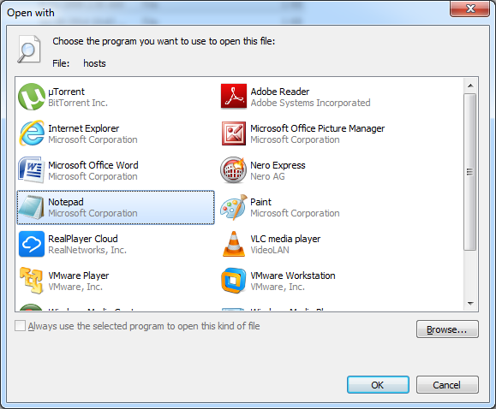

1. Then add an entry as below

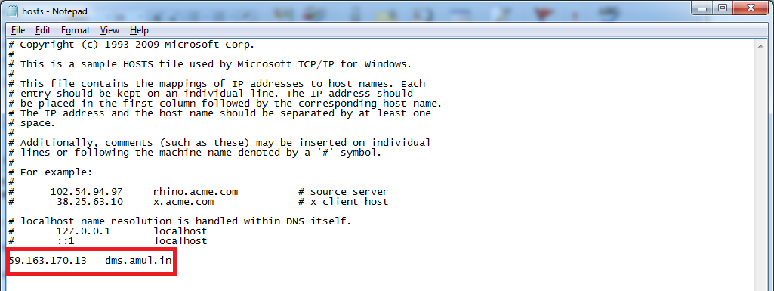

1. Save it and then start the sync process

**For Windows 7**

1. Right Click on the Notepad and select " Runs as Administrator"
2. Open the Hosts files

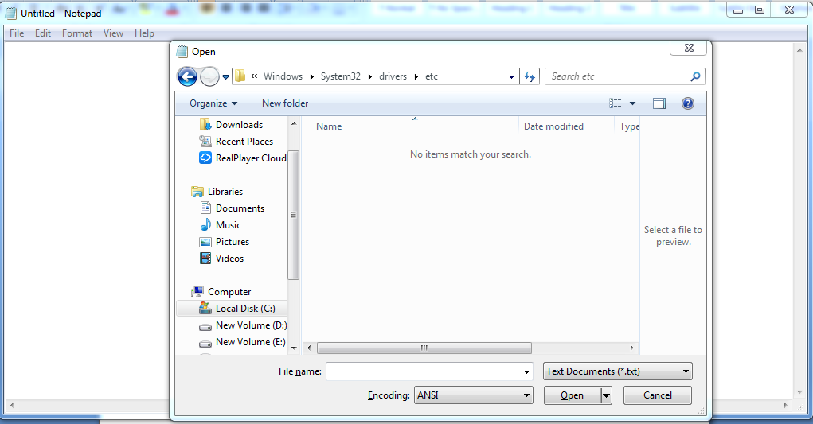

1. Select "All Files"

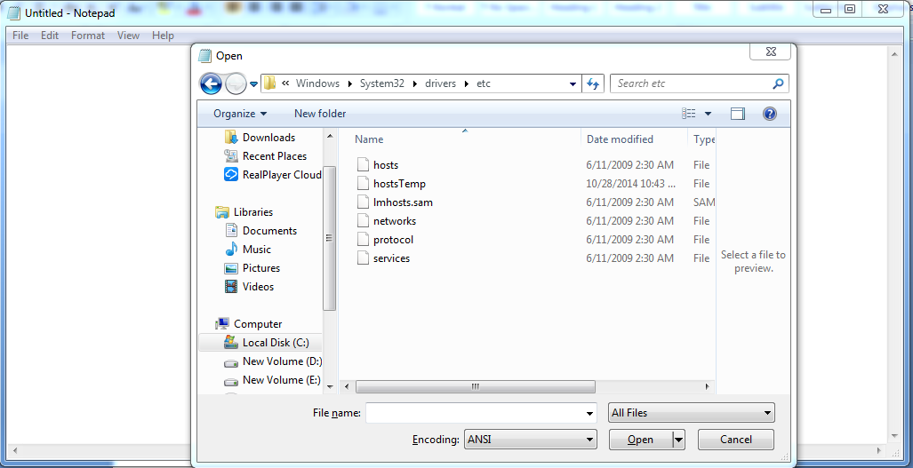

1. Open "hosts" files and give the entry as below



1. Save it and then start the sync process